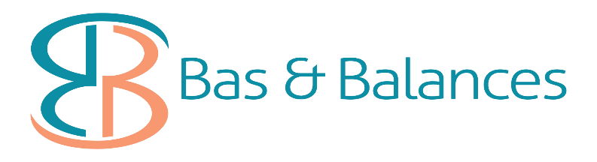
Cash Flow Boost for Employers
Unravelling the stimulus package for PAYGW rebates for those small businesses with staff, NFP and the Business Boost Payment of $50,000
#COVID19PAYGW Stimulus breakdown
If you have any questions in relation to the following information do not hesitate to contact our office on 08 92933660 or email info@basandbalances.com.au and one of our friendly BAS Agents will be able to assist you with your individual enquiry.

The Boosting Cash Flow for Employers payment will be applied to a limited number of activity statement lodgments.
The ATO will deliver the payment as a credit to the entity upon lodgment of their activity statements.
Where this places the entity in a refund position, the ATO will deliver the refund within 14 days.
The minimum payment will be applied to the entities’ first lodgment.

PAYGW is capped at $50,000 for small and medium sized businesses with aggregated annual turnover under $50 million.
Business Boost of $50,000 will be paid in 4 instalments of $12,500 from June to September directly to the business to help pay for overheads such as wages, rent, electricity, to help business stay alive.

Monthly IAS: The amount of PAYGW credited is based on the last lodgement received ie March BAS including wages figures for March 2020
For the sake of this exercise, we are using the amount of $1500 as the March PAYGW figure.
- All amounts in relation to PAYGW will be credited to your ATO Integrated Client Account.
- This amount can be left as a credit to offset ATO liabilities, or if you pay your liabilities each month, you can have the amount released to your bank account*

March 2020 – based on the amount of PAYGW for the month of March, this amount will be credited to your ATO Integrated Client Account. The amount will be 3 x the march amount of PAYG ie: if your PAYGW is $1500 for March, you will be credited $4500 covering January, February, March PAYGW.
- April 2020 – the amount of $1500 PAYGW credited
- May 2020 – the amount of $1500 PAYGW credited
- June 2020 – the first of the business $12500 is paid to the business
- July 2020 – the second business boost of $12,500 is paid to the business
- August 2020 – the third business boost of $12,500 is paid to the business
- September 2020 – the fourth and final business boost is paid to the business

Quarterly Lodgers: The amount of PAYGW credited is based on the last lodgement received ie: March BAS including wages from January – March 2020
- Will receive the payment for the quarters ending March and June 2020
- Business Boost will be received the same as above

*authorisation form to allow us to request this refund from the ATO using the BAS Agent Portal is to be signed and returned to us to have this actioned.
Following examples extracted from the website: www.treasury.gov.au

Case Study #1
Sarah’s Construction Business
Sarah owns and runs a building business in South Australia and employs 8 construction workers on average full-time weekly earnings, who each earn $89,730 per year.
Sarah reports withholding of $15,008 for her employees on each of her monthly Business Activity Statements (BAS).
Under the Government’s changes, Sarah will be eligible to receive the payment on lodgment of her BAS.
Sarah’s business receives:
• A credit of $45,024 for the March period, equal to 300 per cent of her total withholding.
• A credit of $4,976 for the April period, before she reaches the $50,000 cap.
• No payment for the May period, as she has now reached the $50,000 cap.
• An additional payment of $12,500 for the June period, equal to 25 per cent of her total Boosting Cash Flow for Employers payments.
• An additional payment of $12,500 for the July period, equal to 25 per cent of her total Boosting Cash Flow for Employers payments.
• An additional payment of $12,500 for the August period, equal to 25 per cent of her total Boosting Cash Flow for Employers payments.
• An additional payment of $12,500 for the September period, equal to 25 per cent of her total Boosting Cash Flow for Employers payments.
Under the previously announced Boosting Cash Flow for Employers measure, Sarah’s business would have received a maximum payment of $25,000.
Under the Government’s enhanced Boosting Cash Flow for Employers measure, Sarah’s business will receive $100,000. This is an additional $75,000 to support her business and help her retain her staff.

